BÀI THỰC HÀNH LAB 6
Họ và tên : Đặng Đình An
Lớp: 11_THMT
MSSV:1150080001

Thread và Multithreading
MainActivity.java
package com.example.lab6;
import android.content.Intent;
import android.os.Bundle;
import android.os.Handler;
import android.os.Message;
import android.widget.Button;
import android.widget.ProgressBar;
import android.widget.TextView;
import android.widget.Toast;
import androidx.appcompat.app.AppCompatActivity;
import java.util.Random;
public class MainActivity extends AppCompatActivity {
// --- Nút menu ---
private Button btnLab1, btnLab2, btnLab3, btnLab4, btnLab5;
// --- Biến bài 1 ---
private ProgressBar pbFirst, pbSecond;
private TextView tvWorking, tvReturned;
private Button btnStart, btnBack;
private boolean isRunning = false;
private int intTest = 0;
private Handler handler;
private Thread bgThread;
@Override
protected void onCreate(Bundle savedInstanceState) {
super.onCreate(savedInstanceState);
showMainMenu(); // hiển thị menu chính
}
// ================= MENU ==================
private void showMainMenu() {
setContentView(R.layout.activity_main);
btnLab1 = findViewById(R.id.btn_lab1);
btnLab2 = findViewById(R.id.btn_lab2);
btnLab3 = findViewById(R.id.btn_lab3);
btnLab4 = findViewById(R.id.btn_lab4);
btnLab5 = findViewById(R.id.btn_lab5);
// Bài 1 (Thread + Handler)
btnLab1.setOnClickListener(v -> runThreadExample());
// Bài 2–5 (chuyển Activity)
btnLab2.setOnClickListener(v ->
startActivity(new Intent(this, PostActivity.class)));
btnLab3.setOnClickListener(v ->
startActivity(new Intent(this, Main3Activity.class)));
btnLab4.setOnClickListener(v ->
startActivity(new Intent(this, MusicActivity.class)));
btnLab5.setOnClickListener(v ->
startActivity(new Intent(this, MusicRxActivity.class)));
}
// ================= BÀI 1 ==================
private void runThreadExample() {
// Gán layout bài 1 (nhớ đã có file activity_thread_message.xml)
setContentView(R.layout.activity_thread_message);
pbFirst = findViewById(R.id.pb_first);
pbSecond = findViewById(R.id.pb_second);
tvWorking = findViewById(R.id.tv_working);
tvReturned = findViewById(R.id.tv_return);
btnStart = findViewById(R.id.btn_start);
btnBack = findViewById(R.id.btn_back); // nút quay về menu
handler = new Handler(msg -> {
int randomValue = (int) msg.obj;
int progress = msg.arg1;
String text = "Returned by background thread: " + randomValue +
"\nGlobal value: " + intTest;
tvReturned.setText(text);
pbFirst.setProgress(progress);
pbSecond.setProgress(progress);
return true;
});
btnStart.setOnClickListener(v -> startThread());
btnBack.setOnClickListener(v -> {
isRunning = false;
showMainMenu();
});
}
private void startThread() {
if (isRunning) return;
isRunning = true;
intTest = 0;
pbFirst.setProgress(0);
pbSecond.setProgress(0);
tvWorking.setText("Working...");
tvReturned.setText("");
bgThread = new Thread(() -> {
Random random = new Random();
for (int i = 1; i <= 100 && isRunning; i++) {
intTest++;
int randomNum = random.nextInt(100);
Message msg = handler.obtainMessage(1, i, 0, randomNum);
handler.sendMessage(msg);
try {
Thread.sleep(100);
} catch (InterruptedException e) {
e.printStackTrace();
}
}
runOnUiThread(() -> {
isRunning = false;
tvWorking.setText("Done! Background thread stopped.");
Toast.makeText(MainActivity.this, "Thread finished!", Toast.LENGTH_SHORT).show();
});
});
bgThread.start();
}
@Override
protected void onStop() {
super.onStop();
isRunning = false;
}
}

activity_main.xml
<?xml version="1.0" encoding="utf-8"?>
<ScrollView xmlns:android="http://schemas.android.com/apk/res/android"
android:layout_width="match_parent"
android:layout_height="match_parent"
android:background="#E3F2FD">
<LinearLayout
android:id="@+id/layout_main_menu"
android:orientation="vertical"
android:gravity="center"
android:padding="20dp"
android:layout_width="match_parent"
android:layout_height="wrap_content">
<!-- Tiêu đề -->
<TextView
android:layout_width="wrap_content"
android:layout_height="wrap_content"
android:text="LAB 06 - MULTITHREADING MENU"
android:textSize="20sp"
android:textStyle="bold"
android:textColor="#0D47A1"
android:layout_marginBottom="20dp" />
<!-- Các nút chức năng -->
<Button
android:id="@+id/btn_lab1"
android:layout_width="match_parent"
android:layout_height="wrap_content"
android:text="Bài 1"
android:backgroundTint="#1976D2"
android:textColor="#FFFFFF" />
<Button
android:id="@+id/btn_lab2"
android:layout_width="match_parent"
android:layout_height="wrap_content"
android:text="Bài 2"
android:layout_marginTop="10dp"
android:backgroundTint="#1976D2"
android:textColor="#FFFFFF" />
<Button
android:id="@+id/btn_lab3"
android:layout_width="match_parent"
android:layout_height="wrap_content"
android:text="Bài 3"
android:layout_marginTop="10dp"
android:backgroundTint="#1976D2"
android:textColor="#FFFFFF" />
<Button
android:id="@+id/btn_lab4"
android:layout_width="match_parent"
android:layout_height="wrap_content"
android:text="Bài 4"
android:layout_marginTop="10dp"
android:backgroundTint="#1976D2"
android:textColor="#FFFFFF" />
<Button
android:id="@+id/btn_lab5"
android:layout_width="match_parent"
android:layout_height="wrap_content"
android:text="Bài 5"
android:layout_marginTop="10dp"
android:backgroundTint="#1976D2"
android:textColor="#FFFFFF" />
</LinearLayout>
</ScrollView>
Kết quả
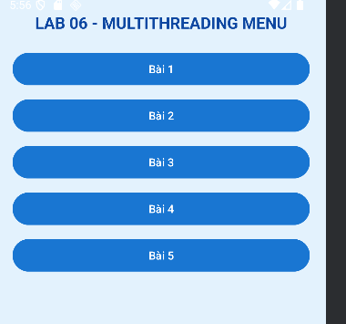

Bài 1
ThreadMesageActivity.java
package com.example.lab6;
import android.os.Bundle;
import android.os.Handler;
import android.os.Message;
import android.widget.Button;
import android.widget.ProgressBar;
import android.widget.TextView;
import android.widget.Toast;
import androidx.appcompat.app.AppCompatActivity;
import java.util.Random;
public class ThreadMessageActivity extends AppCompatActivity {
private ProgressBar pbFirst, pbSecond;
private TextView tvWorking, tvReturned;
private Button btnStart;
private boolean isRunning = false;
private int intTest = 0;
private Handler handler;
private Thread bgThread;
@Override
protected void onCreate(Bundle savedInstanceState) {
super.onCreate(savedInstanceState);
setContentView(R.layout.activity_thread_message); // nhớ tạo layout này
pbFirst = findViewById(R.id.pb_first);
pbSecond = findViewById(R.id.pb_second);
tvWorking = findViewById(R.id.tv_working);
tvReturned = findViewById(R.id.tv_return);
btnStart = findViewById(R.id.btn_start);
handler = new Handler(msg -> {
int randomValue = (int) msg.obj;
int progress = msg.arg1;
String text = "Returned by background thread: " + randomValue +
"\nGlobal value: " + intTest;
tvReturned.setText(text);
pbFirst.setProgress(progress);
pbSecond.setProgress(progress);
return true;
});
btnStart.setOnClickListener(v -> startThread());
}
private void startThread() {
if (isRunning) return;
isRunning = true;
intTest = 0;
pbFirst.setProgress(0);
pbSecond.setProgress(0);
tvWorking.setText("Working...");
tvReturned.setText("");
bgThread = new Thread(() -> {
Random random = new Random();
for (int i = 1; i <= 100 && isRunning; i++) {
intTest++;
int randomNum = random.nextInt(100);
Message msg = handler.obtainMessage(1, i, 0, randomNum);
handler.sendMessage(msg);
try {
Thread.sleep(100);
} catch (InterruptedException e) {
e.printStackTrace();
}
}
runOnUiThread(() -> {
isRunning = false;
tvWorking.setText("Done! Background thread stopped.");
Toast.makeText(ThreadMessageActivity.this, "Thread finished!", Toast.LENGTH_SHORT).show();
});
});
bgThread.start();
}
@Override
protected void onStop() {
super.onStop();
isRunning = false;
}
}

activity_thread_message.xml
<?xml version="1.0" encoding="utf-8"?>
<LinearLayout xmlns:android="http://schemas.android.com/apk/res/android"
android:layout_width="match_parent"
android:layout_height="match_parent"
android:gravity="center"
android:orientation="vertical"
android:padding="20dp"
android:background="#E3F2FD"> <!-- 🌿 Nền xanh nhạt -->
<TextView
android:id="@+id/tv_working"
android:layout_width="match_parent"
android:layout_height="wrap_content"
android:text="Working..."
android:textColor="#0D47A1"
android:textStyle="bold"
android:textSize="18sp"
android:gravity="center"
android:layout_marginBottom="10dp" />
<!-- Thanh tiến trình xanh -->
<ProgressBar
android:id="@+id/pb_first"
android:layout_width="match_parent"
android:layout_height="wrap_content"
style="?android:attr/progressBarStyleHorizontal"
android:progressTint="#1976D2"
android:max="100"
android:layout_marginTop="5dp" />
<ProgressBar
android:id="@+id/pb_second"
android:layout_width="match_parent"
android:layout_height="wrap_content"
style="?android:attr/progressBarStyleHorizontal"
android:progressTint="#1976D2"
android:max="100"
android:layout_marginTop="10dp" />
<TextView
android:id="@+id/tv_return"
android:layout_width="match_parent"
android:layout_height="wrap_content"
android:layout_marginTop="10dp"
android:text="Returned by background thread: ..."
android:textColor="#0D47A1" />
<Button
android:id="@+id/btn_start"
android:layout_width="match_parent"
android:layout_height="wrap_content"
android:text="Start"
android:textColor="#FFFFFF"
android:backgroundTint="#1976D2"
android:layout_marginTop="20dp"
android:padding="10dp" />
<!-- Nút quay về menu -->
<Button
android:id="@+id/btn_back"
android:layout_width="match_parent"
android:layout_height="wrap_content"
android:text="Quay về menu"
android:textColor="#FFFFFF"
android:backgroundTint="#1976D2"
android:layout_marginTop="10dp"
android:padding="10dp" />
</LinearLayout>
Kết quả
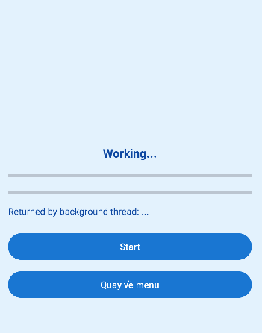
Bài 2:
PostActivity.java
package com.example.lab6;
import android.os.Bundle;
import android.os.Handler;
import android.widget.Button;
import android.widget.EditText;
import android.widget.ProgressBar;
import android.widget.TextView;
import android.widget.Toast;
import androidx.appcompat.app.AppCompatActivity;
public class PostActivity extends AppCompatActivity {
private ProgressBar pbWaiting;
private TextView tvTopCaption;
private EditText etInput;
private Button btnExecute;
private int globalValue;
private Handler handler;
private Runnable bgRunnable, fgRunnable;
@Override
protected void onCreate(Bundle savedInstanceState) {
super.onCreate(savedInstanceState);
setContentView(R.layout.activity_post);
pbWaiting = findViewById(R.id.pb_waiting);
tvTopCaption = findViewById(R.id.tv_top_caption);
etInput = findViewById(R.id.et_input);
btnExecute = findViewById(R.id.btn_execute);
handler = new Handler();
bgRunnable = () -> {
for (int i = 0; i <= 100; i++) {
globalValue++;
handler.post(() -> pbWaiting.setProgress(globalValue % 100));
try {
Thread.sleep(1000);
} catch (InterruptedException e) {
e.printStackTrace();
}
}
handler.post(() -> tvTopCaption.setText("Background work is over!"));
};
fgRunnable = () -> globalValue += 100;
btnExecute.setOnClickListener(v -> {
String data = etInput.getText().toString();
Toast.makeText(this, data, Toast.LENGTH_SHORT).show();
new Thread(bgRunnable).start();
handler.post(fgRunnable);
});
}
}
activity_post.xml
<?xml version="1.0" encoding="utf-8"?>
<LinearLayout xmlns:android="http://schemas.android.com/apk/res/android"
android:layout_width="match_parent"
android:layout_height="match_parent"
android:orientation="vertical"
android:padding="20dp"
android:background="#E3F2FD"> <!-- Nền xanh nhạt -->
<!-- Tiêu đề -->
<TextView
android:id="@+id/tv_top_caption"
android:layout_width="match_parent"
android:layout_height="wrap_content"
android:text="Background test"
android:textSize="18sp"
android:textStyle="bold"
android:textColor="#0D47A1"
android:gravity="center"
android:layout_marginBottom="10dp" />
<!-- Thanh tiến trình -->
<ProgressBar
android:id="@+id/pb_waiting"
style="?android:attr/progressBarStyleHorizontal"
android:layout_width="match_parent"
android:layout_height="wrap_content"
android:progressTint="#1976D2"
android:layout_marginBottom="15dp" />
<!-- Ô nhập liệu -->
<EditText
android:id="@+id/et_input"
android:layout_width="match_parent"
android:layout_height="wrap_content"
android:hint="Nhập dữ liệu tại đây"
android:backgroundTint="#1976D2"
android:textColor="#0D47A1"
android:textColorHint="#64B5F6"
android:layout_marginBottom="15dp"
android:padding="10dp" />
<!-- Nút thực thi -->
<Button
android:id="@+id/btn_execute"
android:layout_width="match_parent"
android:layout_height="wrap_content"
android:text="Thực thi"
android:textColor="#FFFFFF"
android:backgroundTint="#1976D2"
android:padding="10dp"
android:layout_gravity="center"
android:layout_marginTop="10dp" />
</LinearLayout>
Kết quả
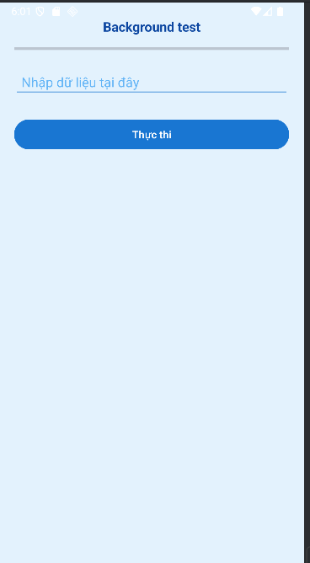

Bài 3:
Main3Activity.java
package com.example.lab6;
import android.app.ProgressDialog;
import android.os.AsyncTask;
import android.os.Bundle;
import android.widget.Button;
import android.widget.TextView;
import androidx.appcompat.app.AppCompatActivity;
import java.text.SimpleDateFormat;
import java.util.Date;
public class Main3Activity extends AppCompatActivity {
private Button btnQuickJob, btnSlowJob;
private TextView tvStatus;
private SlowTask slowTask;
@Override
protected void onCreate(Bundle savedInstanceState) {
super.onCreate(savedInstanceState);
setContentView(R.layout.activity_async);
btnQuickJob = findViewById(R.id.btn_quick_job);
btnSlowJob = findViewById(R.id.btn_slow_job);
tvStatus = findViewById(R.id.tv_status);
slowTask = new SlowTask(tvStatus, this);
btnQuickJob.setOnClickListener(v -> {
SimpleDateFormat sdf = new SimpleDateFormat("dd/MM/yyyy HH:mm:ss");
tvStatus.setText(sdf.format(new Date()));
});
btnSlowJob.setOnClickListener(v -> slowTask.execute());
}
private static class SlowTask extends AsyncTask<Void, Integer, Void> {
private TextView tv;
private ProgressDialog dialog;
public SlowTask(TextView tv, AppCompatActivity act) {
this.tv = tv;
dialog = new ProgressDialog(act);
dialog.setMessage("Some SLOW job is being done. Please wait...");
}
@Override
protected void onPreExecute() {
dialog.show();
}
@Override
protected Void doInBackground(Void... voids) {
for (int i = 1; i <= 5; i++) {
publishProgress(i);
try {
Thread.sleep(2000);
} catch (InterruptedException e) {
e.printStackTrace();
}
}
return null;
}
@Override
protected void onProgressUpdate(Integer... values) {
tv.setText("Progress: " + values[0]);
}
@Override
protected void onPostExecute(Void unused) {
dialog.dismiss();
tv.setText("Done!");
}
}
}
activity_async.xml
<?xml version="1.0" encoding="utf-8"?>
<LinearLayout xmlns:android="http://schemas.android.com/apk/res/android"
android:layout_width="match_parent"
android:layout_height="match_parent"
android:orientation="vertical"
android:padding="10dp">
<TextView
android:id="@+id/tv_status"
android:layout_width="match_parent"
android:layout_height="wrap_content"
android:textSize="16sp" />
<LinearLayout
android:layout_width="match_parent"
android:layout_height="wrap_content"
android:orientation="horizontal"
android:layout_marginTop="10dp">
<Button
android:id="@+id/btn_quick_job"
android:layout_width="0dp"
android:layout_height="wrap_content"
android:layout_weight="1"
android:text="Quick Job" />
<Button
android:id="@+id/btn_slow_job"
android:layout_width="0dp"
android:layout_height="wrap_content"
android:layout_weight="1"
android:text="Slow Job"
android:layout_marginLeft="5dp"/>
</LinearLayout>
</LinearLayout>
Kết quả


Bài 4:
MusicActivity.java
package com.example.lab6;
import android.media.MediaPlayer;
import android.os.AsyncTask;
import android.os.Bundle;
import android.widget.Button;
import android.widget.TextView;
import androidx.appcompat.app.AppCompatActivity;
public class MusicActivity extends AppCompatActivity {
private Button btnPlay, btnStop;
private TextView tvStatus;
private MediaPlayer mediaPlayer;
private PlayMusicTask playMusicTask;
@Override
protected void onCreate(Bundle savedInstanceState) {
super.onCreate(savedInstanceState);
setContentView(R.layout.activity_music);
btnPlay = findViewById(R.id.btn_play);
btnStop = findViewById(R.id.btn_stop);
tvStatus = findViewById(R.id.tv_status);
btnPlay.setOnClickListener(v -> {
playMusicTask = new PlayMusicTask();
playMusicTask.execute();
});
btnStop.setOnClickListener(v -> stopMusic());
}
private void stopMusic() {
if (mediaPlayer != null && mediaPlayer.isPlaying()) {
mediaPlayer.stop();
mediaPlayer.release();
mediaPlayer = null;
tvStatus.setText("Music stopped!");
}
}
private class PlayMusicTask extends AsyncTask<Void, String, Void> {
@Override
protected void onPreExecute() {
tvStatus.setText("Preparing to play...");
}
@Override
protected Void doInBackground(Void... voids) {
publishProgress("Loading...");
mediaPlayer = MediaPlayer.create(MusicActivity.this, R.raw.sample);
mediaPlayer.setOnCompletionListener(mp -> publishProgress("Finished playing."));
publishProgress("Playing...");
mediaPlayer.start();
return null;
}
@Override
protected void onProgressUpdate(String... values) {
tvStatus.setText(values[0]);
}
@Override
protected void onPostExecute(Void unused) {
tvStatus.setText("Playback task done.");
}
}
@Override
protected void onDestroy() {
super.onDestroy();
stopMusic();
}
}
activity_music.xml
<?xml version="1.0" encoding="utf-8"?>
<LinearLayout xmlns:android="http://schemas.android.com/apk/res/android"
android:layout_width="match_parent"
android:layout_height="match_parent"
android:orientation="vertical"
android:gravity="center"
android:padding="16dp"
android:background="#E3F2FD">
<!-- Nút phát nhạc -->
<Button
android:id="@+id/btn_play"
android:layout_width="200dp"
android:layout_height="wrap_content"
android:text="Play Music"
android:textColor="#FFFFFF"
android:backgroundTint="#1976D2"
android:textStyle="bold"
android:padding="10dp" />
<!-- Nút dừng nhạc -->
<Button
android:id="@+id/btn_stop"
android:layout_width="200dp"
android:layout_height="wrap_content"
android:text="Stop Music"
android:textColor="#FFFFFF"
android:backgroundTint="#1976D2"
android:textStyle="bold"
android:padding="10dp"
android:layout_marginTop="10dp" />
<!-- Trạng thái -->
<TextView
android:id="@+id/tv_status"
android:layout_width="wrap_content"
android:layout_height="wrap_content"
android:text="Status: ..."
android:textColor="#0D47A1"
android:textSize="18sp"
android:textStyle="bold"
android:layout_marginTop="20dp" />
</LinearLayout>
Kết quả
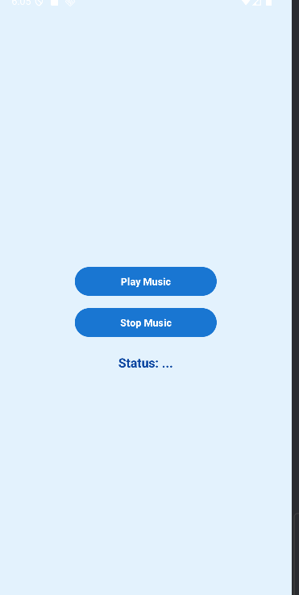

Bài 5:
MusicRxActivity.java
package com.example.lab6;
import android.media.MediaPlayer;
import android.os.Bundle;
import android.widget.Button;
import android.widget.TextView;
import androidx.appcompat.app.AppCompatActivity;
import io.reactivex.rxjava3.android.schedulers.AndroidSchedulers;
import io.reactivex.rxjava3.core.Observable;
import io.reactivex.rxjava3.schedulers.Schedulers;
public class MusicRxActivity extends AppCompatActivity {
private Button btnPlayRx, btnStopRx;
private TextView tvStatusRx;
private MediaPlayer mediaPlayer;
@Override
protected void onCreate(Bundle savedInstanceState) {
super.onCreate(savedInstanceState);
setContentView(R.layout.activity_music_rx);
btnPlayRx = findViewById(R.id.btn_play_rx);
btnStopRx = findViewById(R.id.btn_stop_rx);
tvStatusRx = findViewById(R.id.tv_status_rx);
btnPlayRx.setOnClickListener(v -> playMusicRx());
btnStopRx.setOnClickListener(v -> stopMusic());
}
private void playMusicRx() {
tvStatusRx.setText("Starting...");
Observable.fromCallable(() -> {
mediaPlayer = MediaPlayer.create(MusicRxActivity.this, R.raw.sample);
mediaPlayer.start();
return "Music playing...";
})
.subscribeOn(Schedulers.io()) // chạy trên background
.observeOn(AndroidSchedulers.mainThread()) // cập nhật UI
.subscribe(status -> tvStatusRx.setText(status),
throwable -> tvStatusRx.setText("Error: " + throwable.getMessage()),
() -> tvStatusRx.setText("Music finished!"));
}
private void stopMusic() {
if (mediaPlayer != null && mediaPlayer.isPlaying()) {
mediaPlayer.stop();
mediaPlayer.release();
mediaPlayer = null;
tvStatusRx.setText("Music stopped!");
}
}
@Override
protected void onDestroy() {
super.onDestroy();
stopMusic();
}
}
activity_music_rx.xml
<?xml version="1.0" encoding="utf-8"?>
<LinearLayout xmlns:android="http://schemas.android.com/apk/res/android"
android:layout_width="match_parent"
android:layout_height="match_parent"
android:orientation="vertical"
android:gravity="center"
android:padding="16dp"
android:background="#E3F2FD"> <!-- 🌿 Nền xanh nhạt -->
<!-- Nút Play -->
<Button
android:id="@+id/btn_play_rx"
android:layout_width="200dp"
android:layout_height="wrap_content"
android:text="Play (RxJava)"
android:textColor="#FFFFFF"
android:backgroundTint="#1976D2"
android:padding="10dp"
android:textStyle="bold" />
<!-- Nút Stop -->
<Button
android:id="@+id/btn_stop_rx"
android:layout_width="200dp"
android:layout_height="wrap_content"
android:text="Stop"
android:textColor="#FFFFFF"
android:backgroundTint="#1976D2"
android:padding="10dp"
android:textStyle="bold"
android:layout_marginTop="10dp" />
<!-- TextView hiển thị trạng thái -->
<TextView
android:id="@+id/tv_status_rx"
android:layout_width="wrap_content"
android:layout_height="wrap_content"
android:textSize="18sp"
android:textColor="#0D47A1"
android:layout_marginTop="20dp"
android:textStyle="bold" />
</LinearLayout>
Kết quả
